Assignment-14.1

## Name: P. Umesh Reddy                    Roll No: 2403a510f9

## Batch No: 06                                   Course: Ai Assisted Coding

Task 1 – Portfolio Website Design   
You are building a personal portfolio website to showcase your work.   
Requirements:   
• Create sections for About Me, Projects, and Contact.   
• Use AI to:   
o Suggest color palettes and typography.   
o Create a responsive layout with Grid/Flexbox.   
o Add smooth scrolling navigation.

#Prompt: Design a modern, responsive personal portfolio website featuring sections for About Me, Projects, and Contact. Incorporate AI suggestions for color palettes and typography, utilize Flexbox/Grid for layout, and include smooth scrolling navigation. Provide complete HTML, CSS, and JavaScript code for implementation

Code:

<!DOCTYPE html>

<html lang="en">

<head>

  <meta charset="UTF-8" />

  <meta name="viewport" content="width=device-width, initial-scale=1" />

  <title>Portfolio - Your Name</title>

  <style>

    /* Color palette */

    :root {

      --primary-color: #2c3e50;   /* Dark Blue */

      --secondary-color: #18bc9c; /* Turquoise */

      --accent-color: #e67e22;    /* Orange */

      --bg-color: #ecf0f1;        /* Light Gray */

      --text-color: #34495e;      /* Medium Blue-gray */

      --font-primary: 'Montserrat', sans-serif;

      --font-secondary: 'Roboto', sans-serif;

    }

    * {

      box-sizing: border-box;

      scroll-behavior: smooth;

    }

    body {

      margin: 0;

      font-family: var(--font-primary);

      background-color: var(--bg-color);

      color: var(--text-color);

      line-height: 1.6;

    }

    a {

      color: var(--secondary-color);

      text-decoration: none;

      transition: color 0.3s ease;

    }

    a:hover {

      color: var(--accent-color);

    }

    header {

      position: fixed;

      width: 100%;

      top: 0;

      background: var(--primary-color);

      padding: 1rem 2rem;

      display: flex;

      justify-content: space-between;

      align-items: center;

      z-index: 1000;

      box-shadow: 0 2px 4px rgba(0,0,0,0.2);

    }

    header h1 {

      margin: 0;

      font-size: 1.5rem;

      color: #fff;

      font-weight: 700;

    }

    nav ul {

      list-style: none;

      display: flex;

      gap: 1.5rem;

      margin: 0;

      padding: 0;

    }

    nav li {

      font-weight: 500;

      font-size: 1rem;

    }

    main {

      padding-top: 80px; /* space for fixed header */

      display: flex;

      flex-direction: column;

      gap: 4rem;

      max-width: 960px;

      margin: 0 auto;

      padding-left: 1rem;

      padding-right: 1rem;

    }

    section {

      background: #fff;

      padding: 2rem;

      border-radius: 12px;

      box-shadow: 0 8px 16px rgba(0,0,0,0.1);

    }

    h2 {

      font-family: var(--font-secondary);

      font-size: 2rem;

      border-bottom: 3px solid var(--secondary-color);

      padding-bottom: 0.3rem;

      margin-bottom: 1.5rem;

      color: var(--primary-color);

    }

    #about p {

      font-size: 1.1rem;

      max-width: 680px;

    }

    #projects {

      display: grid;

      grid-template-columns: repeat(auto-fit, minmax(280px, 1fr));

      gap: 1.8rem;

    }

    .project-card {

      border: 2px solid var(--secondary-color);

      border-radius: 10px;

      padding: 1.5rem;

      display: flex;

      flex-direction: column;

      justify-content: space-between;

      transition: transform 0.3s ease, box-shadow 0.3s ease;

      background: #fafafa;

    }

    .project-card:hover {

      transform: translateY(-10px);

      box-shadow: 0 12px 24px rgba(24, 188, 156, 0.3);

    }

    .project-card h3 {

      margin: 0 0 1rem 0;

      color: var(--accent-color);

      font-family: var(--font-secondary);

    }

    .project-card p {

      flex-grow: 1;

      color: var(--text-color);

      margin-bottom: 1rem;

    }

    .project-card a {

      align-self: flex-start;

      font-weight: 600;

    }

    #contact form {

      display: flex;

      flex-direction: column;

      gap: 1rem;

      max-width: 480px;

    }

    #contact label {

      font-weight: 600;

    }

    #contact input, #contact textarea {

      padding: 0.8rem;

      border: 2px solid var(--secondary-color);

      border-radius: 6px;

      font-size: 1rem;

      font-family: var(--font-primary);

      transition: border-color 0.3s ease;

    }

    #contact input:focus, #contact textarea:focus {

      outline: none;

      border-color: var(--accent-color);

      background: #fff;

    }

    #contact button {

      padding: 1rem;

      font-size: 1.1rem;

      border: none;

      border-radius: 8px;

      background: var(--secondary-color);

      color: #fff;

      font-weight: 700;

      cursor: pointer;

      transition: background-color 0.3s ease;

    }

    #contact button:hover {

      background: var(--accent-color);

    }

    @media (max-width: 600px) {

      nav ul {

        flex-direction: column;

        background: var(--primary-color);

        position: fixed;

        top: 60px;

        right: -200px;

        width: 180px;

        transition: right 0.3s ease;

        border-radius: 8px 0 0 8px;

        padding: 1rem;

      }

      nav ul.open {

        right: 0;

      }

      nav li {

        margin-bottom: 1rem;

        font-size: 1.2rem;

      }

      .menu-toggle {

        display: block;

        cursor: pointer;

        color: #fff;

        font-size: 1.4rem;

        user-select: none;

      }

    }

    .menu-toggle {

      display: none;

    }

  </style>

</head>

<body>

  <header>

    <h1>P. Umesh Reddy </h1>

    <nav>

      <span class="menu-toggle" id="menuToggle">☰</span>

      <ul id="navList">

        <li><a href="#about">About Me</a></li>

        <li><a href="#projects">Projects</a></li>

        <li><a href="#contact">Contact</a></li>

      </ul>

    </nav>

  </header>

  <main>

    <section id="about">

      <h2>About Me</h2>

      <p>Hello! I’m Umesh Reddy a passionate developer/designer dedicated to creating beautiful and functional digital experiences. With experience in web development, UI/UX design, and problem-solving, I enjoy turning ideas into reality using modern technologies.</p>

    </section>

    <section id="projects">

      <h2>Projects</h2>

      <div class="project-card">

        <h3>Project One</h3>

        <p>A responsive web app built with React that helps users track habits and stay productive.</p>

        <a href="#" target="_blank">View Project</a>

      </div>

      <div class="project-card">

        <h3>Project Two</h3>

        <p>An e-commerce website designed with user experience and accessibility in mind.</p>

        <a href="#" target="_blank">View Project</a>

      </div>

      <div class="project-card">

        <h3>Project Three</h3>

        <p>A Python data analytics tool that visualizes social media sentiment trends.</p>

        <a href="#" target="_blank">View Project</a>

      </div>

    </section>

    <section id="contact">

      <h2>Contact</h2>

      <form>

        <label for="name">Name</label>

        <input type="text" id="name" placeholder="Your name" required/>

        <label for="email">Email</label>

        <input type="email" id="email" placeholder="your.email@example.com" required/>

        <label for="message">Message</label>

        <textarea id="message" rows="5" placeholder="Your message here" required></textarea>

        <button type="submit">Send</button>

      </form>

    </section>

  </main>

  <script>

    const menuToggle = document.getElementById('menuToggle');

    const navList = document.getElementById('navList');

    menuToggle.addEventListener('click', () => {

      navList.classList.toggle('open');

    });

    navList.querySelectorAll('a').forEach(link =>

      link.addEventListener('click', () => navList.classList.remove('open'))

    );

  </script>

</body>

</html>

**Output:**

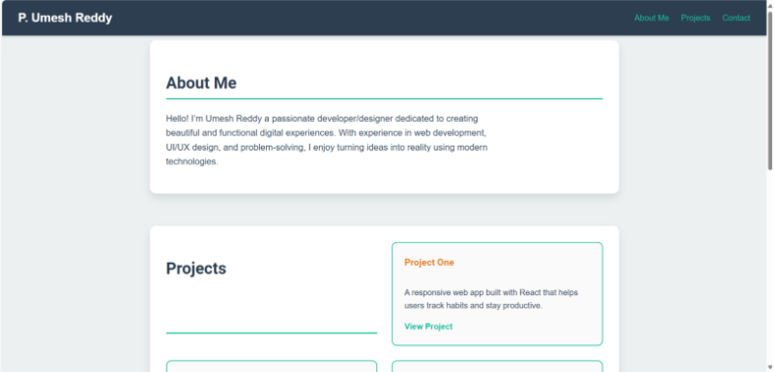 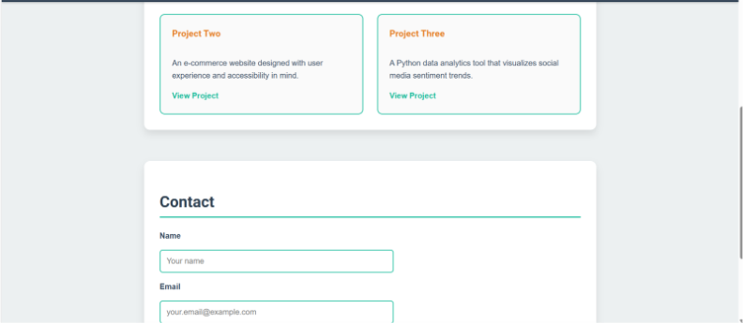 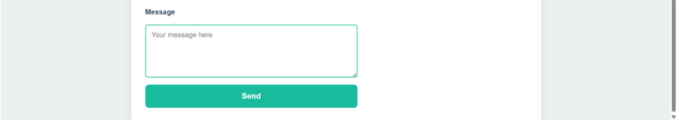

Task 2 – Online Store Product Page   
Design a product display page for an online store.   
Requirements:   
• Display product image, title, price, and "Add to Cart" button.   
• Use AI to:   
o Style with BEM methodology.   
o Make layout responsive.   
o Add hover effects and "Add to Cart" alert

Code:

**<!DOCTYPE html>**

**<html lang="en">**

**<head>**

**<meta charset="UTF-8" />**

**<meta name="viewport" content="width=device-width, initial-scale=1" />**

**<title>Product Gallery - Cool Online Store</title>**

**<style>**

**:root {**

**--primary-color: #1e88e5;**

**--secondary-color: #e53935;**

**--bg-color: #fafafa;**

**--text-color: #333;**

**--font-family: 'Segoe UI', Tahoma, Geneva, Verdana, sans-serif;**

**}**

**body {**

**margin: 0;**

**font-family: var(--font-family);**

**background-color: var(--bg-color);**

**color: var(--text-color);**

**padding: 2rem;**

**display: flex;**

**justify-content: center;**

**}**

**.products {**

**display: grid;**

**grid-template-columns: repeat(auto-fit, minmax(280px, 1fr));**

**gap: 2rem;**

**max-width: 1080px;**

**width: 100%;**

**}**

**.product-card {**

**background: #fff;**

**border-radius: 12px;**

**box-shadow: 0 10px 20px rgba(30, 136, 229, 0.15);**

**overflow: hidden;**

**display: flex;**

**flex-direction: column;**

**transition: transform 0.3s ease, box-shadow 0.3s ease;**

**}**

**.product-card:hover {**

**transform: translateY(-8px);**

**box-shadow: 0 20px 40px rgba(30, 136, 229, 0.3);**

**}**

**.product-card__image {**

**width: 100%;**

**aspect-ratio: 4 / 3;**

**object-fit: cover;**

**border-bottom: 1px solid #ddd;**

**}**

**.product-card__info {**

**padding: 1.2rem 1.5rem;**

**flex-grow: 1;**

**}**

**.product-card__title {**

**font-size: 1.3rem;**

**font-weight: 700;**

**margin: 0 0 0.5rem 0;**

**color: var(--primary-color);**

**}**

**.product-card__price {**

**font-size: 1.1rem;**

**font-weight: 600;**

**margin: 0 0 1.2rem 0;**

**color: var(--secondary-color);**

**}**

**.product-card__button {**

**background-color: var(--primary-color);**

**color: white;**

**border: none;**

**border-radius: 8px;**

**padding: 0.8rem;**

**width: 100%;**

**font-size: 1.1rem;**

**font-weight: 600;**

**cursor: pointer;**

**transition: background-color 0.3s ease;**

**}**

**.product-card__button:hover {**

**background-color: #1565c0;**

**}**

**@media (max-width: 400px) {**

**body {**

**padding: 1rem;**

**}**

**.products {**

**grid-template-columns: 1fr;**

**gap: 1.5rem;**

**}**

**}**

**</style>**

**</head>**

**<body>**

**<section class="products">**

**<article class="product-card">**

**<img src="https://images.unsplash.com/photo-1606813909317-a654bf4c568f?auto=format&fit=crop&w=600&q=80" alt="Wireless Headphones" class="product-card__image" />**

**<div class="product-card__info">**

**<h2 class="product-card__title">Wireless Headphones</h2>**

**<p class="product-card__price">$199.99</p>**

**<button class="product-card__button" data-name="Wireless Headphones">Add to Cart</button>**

**</div>**

**</article>**

**<article class="product-card">**

**<img src="https://images.unsplash.com/photo-1503602642458-232111445657?auto=format&fit=crop&w=600&q=80" alt="Smart Watch" class="product-card__image" />**

**<div class="product-card__info">**

**<h2 class="product-card__title">Smart Watch</h2>**

**<p class="product-card__price">$249.99</p>**

**<button class="product-card__button" data-name="Smart Watch">Add to Cart</button>**

**</div>**

**</article>**

**<article class="product-card">**

**<img src="https://images.unsplash.com/photo-1618224501159-1386e2d0e145?auto=format&fit=crop&w=600&q=80" alt="Gaming Mouse" class="product-card__image" />**

**<div class="product-card__info">**

**<h2 class="product-card__title">Gaming Mouse</h2>**

**<p class="product-card__price">$75.99</p>**

**<button class="product-card__button" data-name="Gaming Mouse">Add to Cart</button>**

**</div>**

**</article>**

**<article class="product-card">**

**<img src="https://images.unsplash.com/photo-1560448204-0c1bc7de7a7a?auto=format&fit=crop&w=600&q=80" alt="Bluetooth Speaker" class="product-card__image" />**

**<div class="product-card__info">**

**<h2 class="product-card__title">Bluetooth Speaker</h2>**

**<p class="product-card__price">$120.50</p>**

**<button class="product-card__button" data-name="Bluetooth Speaker">Add to Cart</button>**

**</div>**

**</article>**

**</section>**

**<script>**

**const buttons = document.querySelectorAll('.product-card__button');**

**buttons.forEach(button => {**

**button.addEventListener('click', () => {**

**const productName = button.getAttribute('data-name');**

**alert(`Added "${productName}" to your cart!`);**

**});**

**});**

**</script>**

**</body>**

**</html>**

**Output:**

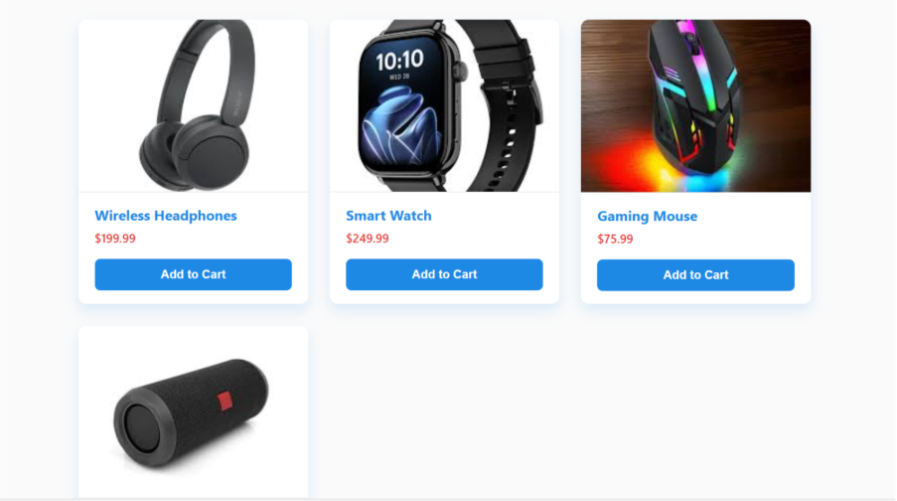 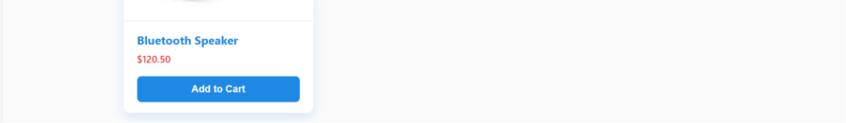

Task 3 – Event Registration Form   
Build an event registration form for a conference.   
Requirements:   
• Collect name, email, phone number, and session selection.   
• Use AI to:   
o Add form validation with JavaScript.   
o Make the form accessible with labels and ARIA.   
o Style with a professional look

<!DOCTYPE html>

<html lang="en">

<head>

  <meta charset="UTF-8" />

  <meta name="viewport" content="width=device-width, initial-scale=1" />

  <title>Conference Registration</title>

  <style>

    @import url('https://fonts.googleapis.com/css2?family=Roboto:wght@400;700&display=swap');

    :root {

      --primary-color: #0073e6;

      --secondary-color: #005bb5;

      --error-color: #e63946;

      --bg-color: #f7f9fc;

      --text-color: #1a1a1a;

      --font-family: 'Roboto', sans-serif;

      --border-radius: 8px;

      --transition: 0.3s ease;

    }

    body {

      font-family: var(--font-family);

      background-color: var(--bg-color);

      color: var(--text-color);

      margin: 0;

      display: flex;

      justify-content: center;

      align-items: center;

      min-height: 100vh;

      padding: 20px;

    }

    .registration-form {

      background: #fff;

      padding: 2.5rem 3rem;

      border-radius: var(--border-radius);

      box-shadow: 0 8px 20px rgba(0,0,0,0.1);

      width: 100%;

      max-width: 450px;

      box-sizing: border-box;

    }

    .registration-form h1 {

      margin-top: 0;

      font-weight: 700;

      font-size: 1.8rem;

      margin-bottom: 1.5rem;

      text-align: center;

      color: var(--primary-color);

    }

    label {

      display: block;

      font-weight: 600;

      margin-bottom: 0.5rem;

      margin-top: 1rem;

    }

    input[type="text"],

    input[type="email"],

    input[type="tel"],

    select {

      width: 100%;

      padding: 0.75rem 1rem;

      font-size: 1rem;

      border: 2px solid #ccc;

      border-radius: var(--border-radius);

      transition: border-color var(--transition);

    }

    input[type="text"]:focus,

    input[type="email"]:focus,

    input[type="tel"]:focus,

    select:focus {

      outline: none;

      border-color: var(--primary-color);

      box-shadow: 0 0 8px rgba(0, 115, 230, 0.25);

    }

    .error-message {

      color: var(--error-color);

      font-size: 0.85rem;

      margin-top: 0.25rem;

      display: none;

    }

    button {

      margin-top: 2rem;

      width: 100%;

      background-color: var(--primary-color);

      border: none;

      color: white;

      padding: 0.9rem;

      font-size: 1.1rem;

      font-weight: 700;

      border-radius: var(--border-radius);

      cursor: pointer;

      transition: background-color var(--transition);

    }

    button:hover {

      background-color: var(--secondary-color);

    }

    /* Accessibility focus styles */

    input:focus-visible,

    select:focus-visible,

    button:focus-visible {

      outline: 3px solid var(--primary-color);

      outline-offset: 2px;

    }

  </style>

</head>

<body>

  <form class="registration-form" id="regForm" aria-labelledby="formTitle" novalidate>

    <h1 id="formTitle">Conference Registration</h1>

    <label for="name">Full Name <span aria-hidden="true" style="color: var(--error-color);">*</span></label>

    <input type="text" id="name" name="name" aria-required="true" aria-describedby="nameError" required minlength="3" />

    <div class="error-message" id="nameError">Please enter at least 3 characters.</div>

    <label for="email">Email Address <span aria-hidden="true" style="color: var(--error-color);">*</span></label>

    <input type="email" id="email" name="email" aria-required="true" aria-describedby="emailError" required />

    <div class="error-message" id="emailError">Please enter a valid email.</div>

    <label for="phone">Phone Number <span aria-hidden="true" style="color: var(--error-color);">*</span></label>

    <input type="tel" id="phone" name="phone" aria-required="true" aria-describedby="phoneError"

      placeholder="e.g. +1 123 456 7890" required pattern="^\+?\d{1,4}[\s.-]?\(?\d+\)?([\s.-]?\d+)*$" />

    <div class="error-message" id="phoneError">Please enter a valid phone number.</div>

    <label for="session">Select Session <span aria-hidden="true" style="color: var(--error-color);">*</span></label>

    <select id="session" name="session" aria-required="true" aria-describedby="sessionError" required>

      <option value="">-- Choose a session --</option>

      <option value="morning">Morning: Future of Technology</option>

      <option value="afternoon">Afternoon: AI and Data Science</option>

      <option value="evening">Evening: Networking & Career Growth</option>

    </select>

    <div class="error-message" id="sessionError">Please select a session.</div>

    <button type="submit" aria-label="Submit registration form">Register</button>

  </form>

  <script>

document.getElementById('regForm').addEventListener('submit', function(event) {

      event.preventDefault();

      const errors = this.querySelectorAll('.error-message');

      errors.forEach(error => error.style.display = 'none');

      let valid = true;

      const nameInput = this.name;

      if (!nameInput.value || nameInput.value.trim().length < 3) {

        document.getElementById('nameError').style.display = 'block';

        valid = false;

      }

      const emailInput = this.email;

      const emailPattern = /^[^\s@]+@[^\s@]+\.[^\s@]+$/;

      if (!emailInput.value || !emailPattern.test(emailInput.value)) {

        document.getElementById('emailError').style.display = 'block';

        valid = false;

      }

      const phoneInput = this.phone;

      const phonePattern = /^\+?\d{1,4}[\s.-]?\(?\d+\)?([\s.-]?\d+)*$/;

      if (!phoneInput.value || !phonePattern.test(phoneInput.value)) {

        document.getElementById('phoneError').style.display = 'block';

        valid = false;

      }

      const sessionInput = this.session;

      if (!sessionInput.value) {

        document.getElementById('sessionError').style.display = 'block';

        valid = false;

      }

      if (valid) {

        alert(`Thank you, ${nameInput.value}, for registering for the ${sessionInput.options[sessionInput.selectedIndex].text} session!`);

        this.reset();

      }

    });

  </script>

</body>

</html>

**Output:**

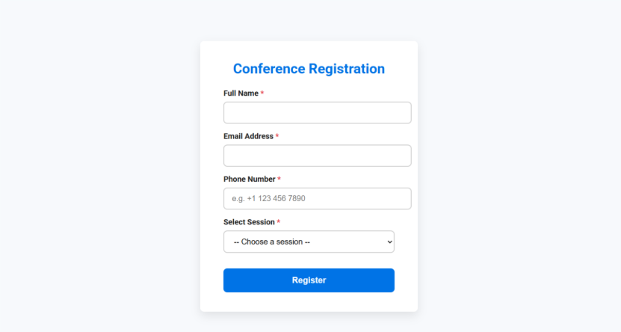

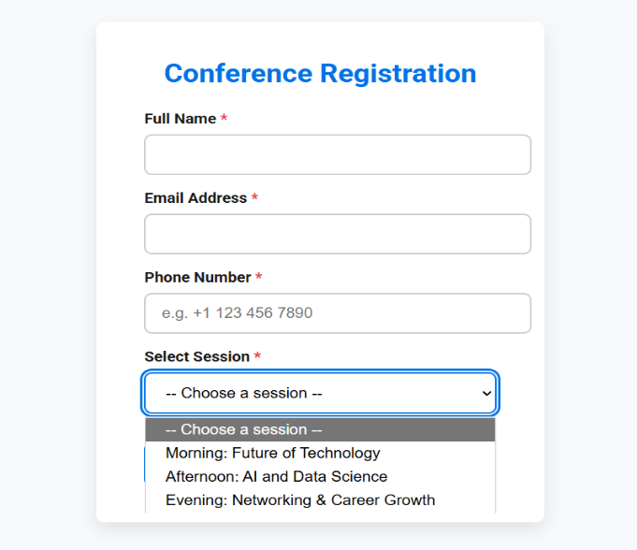

Task Description #4 (Data – Fetch API & Render List with   
Loading/Error States)   
• Task: Fetch JSON from an API and render items to the DOM   
with loading and error UI.   
• Instructions:   
o Ask AI to write fetch() logic, create DOM nodes safely,   
and add skeleton/loading text.

Code:

<!DOCTYPE html>

<html lang="en">

<head>

  <meta charset="UTF-8" />

  <meta name="viewport" content="width=device-width, initial-scale=1" />

  <title>API Data Fetch with Pagination</title>

  <style>

    @import url('https://fonts.googleapis.com/css2?family=Inter:wght@400;600&display=swap');

    :root {

      --primary-color: #4a90e2;

      --error-color: #e74c3c;

      --bg-color: #f5f7fa;

      --text-color: #333;

      --font-family: 'Inter', sans-serif;

      --border-radius: 8px;

      --shadow: 0 4px 12px rgba(74, 144, 226, 0.2);

    }

    body {

      margin: 0;

      font-family: var(--font-family);

      background-color: var(--bg-color);

      color: var(--text-color);

      display: flex;

      justify-content: center;

      padding: 2rem;

      min-height: 100vh;

      box-sizing: border-box;

      flex-direction: column;

      align-items: center;

    }

    .container {

      max-width: 600px;

      width: 100%;

      background: white;

      border-radius: var(--border-radius);

      padding: 1.5rem 2rem;

      box-shadow: var(--shadow);

      box-sizing: border-box;

      margin-bottom: 1.5rem;

    }

    h1 {

      margin-top: 0;

      color: var(--primary-color);

      font-weight: 600;

      text-align: center;

      margin-bottom: 1rem;

    }

    #statusMessage {

      text-align: center;

      font-size: 1rem;

      padding: 0.8rem 0;

      color: var(--primary-color);

      min-height: 1.5rem;

    }

    #statusMessage.error {

      color: var(--error-color);

    }

    ul.data-list {

      list-style: none;

      padding: 0;

      margin: 0;

    }

    ul.data-list li {

      background-color: #f0f4ff;

      margin-bottom: 1rem;

      border-radius: var(--border-radius);

      padding: 1rem 1.2rem;

      box-shadow: inset 0 0 6px rgba(74, 144, 226, 0.15);

      font-weight: 500;

      font-size: 1rem;

    }

    .skeleton {

      background: linear-gradient(90deg, #e0e6ff 25%, #c0ccff 37%, #e0e6ff 63%);

      animation: loading 1.4s infinite ease-in-out;

      border-radius: var(--border-radius);

      height: 1.2rem;

      margin-bottom: 1rem;

      width: 100%;

      max-width: 450px;

    }

    @keyframes loading {

      0% { background-position: 200% 0; }

      100% { background-position: -200% 0; }

    }

    .pagination {

      display: flex;

      gap: 1rem;

      justify-content: center;

    }

    .pagination button {

      background-color: var(--primary-color);

      border: none;

      color: white;

      border-radius: var(--border-radius);

      padding: 0.6rem 1.2rem;

      font-size: 1rem;

      font-weight: 600;

      cursor: pointer;

      transition: background-color 0.3s ease;

      min-width: 80px;

    }

    .pagination button:disabled {

      background-color: #a0c3ff;

      cursor: not-allowed;

    }

    .pagination button:hover:not(:disabled) {

      background-color: #3a6bcc;

    }

  </style>

</head>

<body>

  <div class="container" role="region" aria-live="polite" aria-busy="false">

    <h1>API Data Fetch</h1>

    <div id="statusMessage" aria-live="assertive" aria-atomic="true"></div>

    <ul class="data-list" id="dataList" aria-label="List of items"></ul>

  </div>

  <div class="pagination" role="navigation" aria-label="Pagination navigation">

    <button id="prevBtn" aria-label="Previous page" disabled>Previous</button>

    <button id="nextBtn" aria-label="Next page">Next</button>

  </div>

  <script>

    const API_URL = 'https://jsonplaceholder.typicode.com/posts';

    const dataList = document.getElementById('dataList');

    const statusMessage = document.getElementById('statusMessage');

    const container = document.querySelector('.container');

    const prevBtn = document.getElementById('prevBtn');

    const nextBtn = document.getElementById('nextBtn');

    const ITEMS_PER_PAGE = 5;

    let currentPage = 1;

    let totalItems = 0;

    function showSkeletons(count = ITEMS_PER_PAGE) {

      dataList.innerHTML = '';

      for (let i = 0; i < count; i++) {

        const skeleton = document.createElement('li');

        skeleton.className = 'skeleton';

        dataList.appendChild(skeleton);

      }

    }

    function clearUI() {

      dataList.innerHTML = '';

      statusMessage.textContent = '';

      statusMessage.classList.remove('error');

    }

    function renderItems(items) {

      clearUI();

      items.forEach(item => {

        const li = document.createElement('li');

        li.textContent = item.title;

        dataList.appendChild(li);

      });

    }

    function showError(message) {

      clearUI();

      statusMessage.textContent = message;

      statusMessage.classList.add('error');

    }

    async function fetchData(page) {

      container.setAttribute('aria-busy', 'true');

      statusMessage.classList.remove('error');

      statusMessage.textContent = 'Loading data...';

      showSkeletons();

      try {

        const response = await fetch(`${API_URL}?_limit=${ITEMS_PER_PAGE}&_page=${page}`);

        if (!response.ok) {

          throw new Error(`Error loading data: ${response.status} ${response.statusText}`);

        }

        const data = await response.json();

        totalItems = parseInt(response.headers.get('X-Total-Count')) || 0;

        renderItems(data);

        statusMessage.textContent = `Page ${page} of ${Math.ceil(totalItems / ITEMS_PER_PAGE)}`;

        prevBtn.disabled = page === 1;

        nextBtn.disabled = page >= Math.ceil(totalItems / ITEMS_PER_PAGE);

      } catch (error) {

        showError(error.message);

      } finally {

        container.setAttribute('aria-busy', 'false');

      }

    }

    prevBtn.addEventListener('click', () => {

      if (currentPage > 1) {

        currentPage--;

        fetchData(currentPage);

      }

    });

    nextBtn.addEventListener('click', () => {

      if (currentPage < Math.ceil(totalItems / ITEMS_PER_PAGE)) {

        currentPage++;

        fetchData(currentPage);

      }

    });

    fetchData(currentPage);

  </script>

</body>

</html>

Output:

